The Halcyon Park Neighborhood Association Newsletter

Daniel Natal, President
Norma Borja Kroll, Beautification Coordinator
Jim Blaszak, Traffic Coordinator
Susana Sotillo, Recording Secretary
http://www.halcyonparkhistoricdistrict.com/ This is the new Halcyon Park historic site.
http://www.halcyonpark.org (New URL)
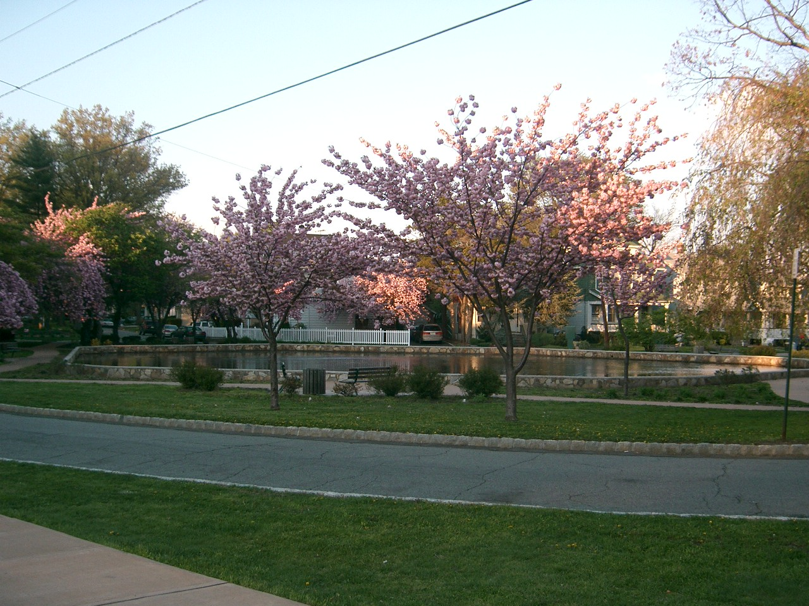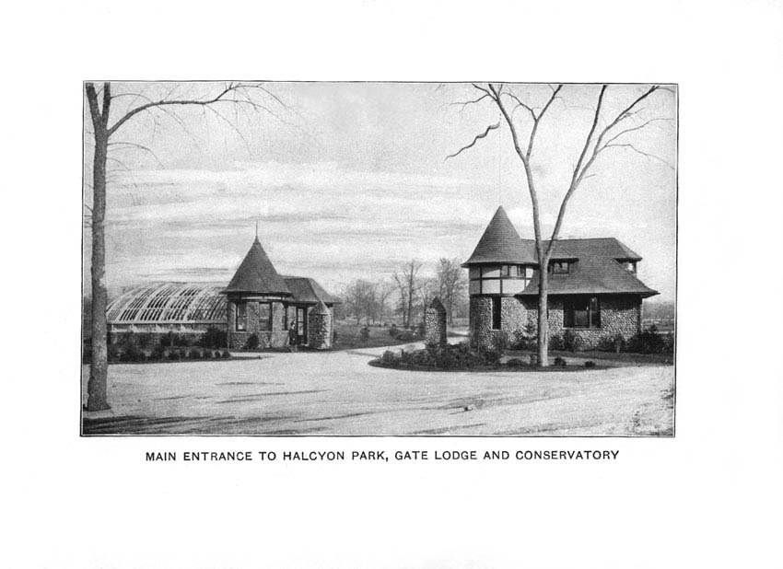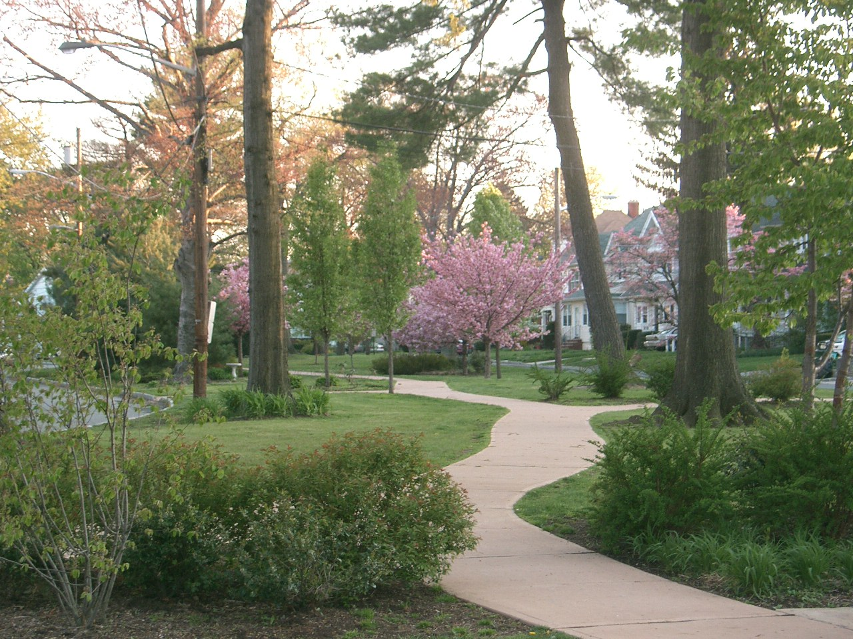 ______________________________________________________________
Spring 2007 (March – May) Volume 5 No.5
President’s Message:

We all welcome spring, one of the most beautiful times of the year. Let us all feel renewed with the sights and sounds of spring.

This has been a difficult winter for most of us, but we are eagerly planning our spring egg hunt for children and would be grateful for some volunteers. If you would like to participate, please call Daniel Natal at 973-259-1337 as soon as possible.

We would like to inform you that the winners of last year’ “holiday decoration contest” were Rich Rockwell-Rodgee Cao, and the family at 149 Lexington Ave., the very entrance to the park from Franklin St. Both families received gift certificates to Staples. We are very grateful to all the families in Halcyon Park who decorated their homes with exquisite taste.

Rich Rockwell has created a beautiful historic web site and is looking into the requirements for having Halcyon Park listed as a historic site. If we were declared a historic site, this would mean that residents interested in restoring their homes to their original design circa 1920 would be able to apply for funding from the state. If you are interested in this topic, please attend the next Bloomfield Neighborhood Associations Committee meeting to be held on Saturday, March 24th, at 10:00 a.m. in the Mayor’s conference room, 2nd Floor, Law Enforcement Bldg. The meeting will be chaired by Patricia Cavanaugh of the Bloomfield Historical Society.

In case anyone is interested in planting a tree in his/her property, please call our town Forester, Stephen Schuckman, at 973-228-2466. Also, if you want him to do a workshop for our children, please contact him at your earliest convenience. We are interested in starting an environmental club here in Halcyon Park.

Congratulations are in order to the owners of 83 Lexington Avenue. They have renovated their residence and installed beautiful iron railings that enhance the value of their property and benefit residents of Halcyon Park by contributing to our quality of life.

Daniel Natal, President
3 Parkway East

"Halcyon Park Historic District"

In 1995 when New Jersey Transit was planning the extension of the Newark City Subway, a report was commissioned to determine if there were any historic properties that might be affected by the light rail line and Vehicle Base Facility. That report concluded that “Halcyon Park Historic District… is eligible for the national Register of Historic Places as an intact collection of early twentieth century residential housing in a planned setting reflecting attention to open space and neighborhood character.” “Houses within Halcyon Park, built between 1905 and 1930, include a number of well-preserved examples of early-twentieth century residential architecture in Bungalow, American Foursquare, Colonial Revival, Tudor, and Queen Anne styles.” Additional excerpts from that report and an “opinion” letter from the Deputy State Historic Preservation Officer concurring with the findings of the report are available at www.HalcyonParkHistoricDistrict.com.

I plan to apply to have Halcyon Park officially registered on the National Register of Historic Places. I created a web site www.HalcyonParkHistoricDistrict.com as a place to collect photographs and other historical information about Halcyon Park and to share that information with others who are interested.

As residents of Halcyon Park, if you have any photographs, articles, postcards or other historic information about Halcyon Park that you can share, please contact me at info@HalcyonParkHistoricDistrict.com. If you have questions, email me and I’ll answer the questions and make a list of Frequently Asked Questions available on the web site.

The first set of photos on the web site are from an 1895 promotional brochure for Halcyon Park.

Rich Rockwell
www.HalcyonParkHistoricDistrict.com
email: info@HalcyonParkHistoricDistrict.com
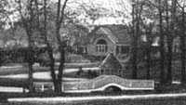

From the desk of the Recording Secretary:

If someone has the time to devote to the HPNA newsletter, I would be grateful if you could contact me at cassandra8@comcast.net. We are looking for young men or women to volunteer to write a monthly column. This could be part of their Community Service internship and would be greatly appreciated. We are also looking for someone with a business background to help us canvas various business owners in this area in order to encourage them to advertise with us. It would offset the costs of printing the newsletter. Ideally, one of our realtors in Halcyon Park should take up the challenge of sponsoring a monthly or quarterly newsletter for this neighborhood.

Several of us who work in higher education are planning to organize a workshop in May for young people planning to attend college. My colleague, Jean Alvares, would be very happy to share his insights with those interested. If anyone is interested in helping us coordinate this, please call Jean at 973-743-0243.

I am urging those of you who are interested in starting a Neighborhood Watch group to contact Captain James Decker, director of Bloomfield’s Community Policing Unit, who also happens to be a member of our Board of Education. Send him an e-mail at decker@bloomfieldtwpnj.com or call the Community Policing Unit at 973-680-4278 or 4106. We need an organizing committee to coordinate our efforts.

Several neighbors have reported seeing “gang” graffiti in our park. We will not tolerate this affront to our quality of life. Please, become involved and take a stand against thugs that threaten to disrupt our lives. Do not wait until an ugly incident occurs and then you have to react defensively. We have seen that happen recently. When feuds among neighbors turn into civil or criminal complaints, everyone loses, not just the aggrieved parties.

Get involved! You live in this community and whatever happens here affects all of us.

Susana M. Sotillo

Meetings of the Township of Bloomfield
The 2007 Annual Meeting Schedule for the Township Council of the Township of Bloomfield, New Jersey, shall be as follows:
Regular Meetings | Conference Meetings

March 19 | 7:30 p.m. | March 26 | 7:00 p.m.
April 2 (Library) | 7:30 p.m. | April 9 | 7:00 p.m.
April 16 | 7:30 p.m. | April 23 | 7:00 p.m.
May 7 | 7:30 p.m. | May 14 | 7:00 p.m.
May 21 (Oakeside) | 7:30 p.m. | May 29 (Tues) | 7:00 p.m.
June 4 | 7:30 p.m. | June 11 | 7:00 p.m.
June 18 | 7:30 p.m. | June 25 | 7:00 p.m.
July 9 | 7:30 p.m. | July 23 | 7:00 p.m.
August 6 | 7:30 p.m. | August 20 | 7:00 p.m.
September 4 (Tues) | 7:30 p.m. | September 10 | 7:00 p.m.
September 17 (Library) | 7:30 p.m. | September 24 | 7:00 p.m.
October 1 | 7:30 p.m. | October 9 (Tues) | 7:00 p.m.
October 15 | 7:30 p.m. | October 22 | 7:00 p.m.
November 7 (Wed)  Conference/Regular | 6/7:30 p.m. | November 19 | 7:00 p.m.
 |  | November 26 | 7:00 p.m.
December 3 | 7:30 p.m. | December 10 | 7:00 p.m.
December 17 (Conf/Reg) | 6/7:30 p.m. | HAPPY HOLIDAYS
All Conference Meetings are held in Room 205 of the Law Enforcement Building. Regular Meetings are held in the Council Chambers of the Municipal Building. All questions should be directed to the Municipal Clerk's Office at (973) 680-4015.
 Bloomfield, NJ, March 12, 2007
Spring Events at the Bloomfield Public Library
Library Hours:
Monday, Tuesday, & Wednesday – 9:30 AM – 9:00 PM
Thursday, Friday & Saturday – 9:30 AM – 5:00 PM
Sundays: 1:00 PM – 5:00 PM
The Library will be closed in observance of Good Friday on Friday, April 6th and of Easter Sunday on Sunday, April 8th. We will close on Saturday, May 26th and reopen on Tuesday, May 29th in observance of the Memorial Day Weekend. The Library closes on Saturdays and Sundays during the summer. Please call or check our website for specific dates.
Improvements
New computer tables provide enhanced privacy and work space for our patrons using public access computers in the Library. New carpeting and a new Information Services Center desk are coming soon.
Movies
Movies are shown on Monday and Thursday afternoons at 12:15 PM in the Library Theatre. Admission is free and all are welcome. Light refreshments are provided. Parents are advised to check ratings of films before bringing children. Patrons may enter the Theatre either through the Broad Street entrance (stairs) or through the (barrier-free) elevator entrance in the parking lot behind the Library.
Homework Help for Children Continues
Bloomfield schoolchildren in grades six and under may obtain free tutoring from 4:00 PM to 6:00 PM on Mondays, Tuesdays, and Wednesdays in the Children’s Department Library building. For more information or to make a special appointment outside of the usual times, please call 973-566-6200, ext. 212.
Support your neighborhood association. Please call Auria at 973-259-1337 for a membership application form.

